Estimating Bzone_Urban-Mixed-Use_Prop.csv
March 4, 2026

Definition of the Input File

VisionEval (https://visioneval.github.io/docs/conceptprimer.html#urban-mixed-use) explains that the definition for bzone_urban_mixed-use_prop.csv that it contains “the target proportion of households located in mixed-used neighborhoods.” In sum, a mixed-use development “is one that includes residential and non-residential land uses in close proximity to one another, allowing for pedestrian access to many desired goods and services.” This proportion is reflected in the attribute MixUseProp shown below in an excerpt of the file which shows these values for three zones: 515400010001 (an urban area near Charlottesville’s downtown pedestrian mall), 510030110004 (a rural residential area in Albemarle County) and 510030107021 (a suburban area near Route 29 in Albemarle County).

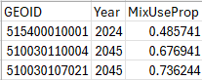

In this instance, the households living in mixed-use neighborhoods is highest for the suburban area (0.74) and lowest for the most urban area (0.49). Thus, as discussed herein, the user may wish to replace these values with local information as discussed in the pages that follow.

Possible Scenario

One possible scenario in VisionEval based on this input file is to examine how changing the number of households that lived in mixed use areas influences daily vehicle miles traveled and greenhouse gas emissions. Such a scenario would entail changes to this file (Bzone_Urban-Mixed-Use_Prop.csv) as well as changes to a related input file, which is the walkability of the zone (bzone_network_design.csv).

Options for Choosing Inputs

Additional documentation suggests that there are two options for defining this target:

- The user can “establish targets for the proportion of households in each Bzone that are located in urban mixed-use neighborhoods.” This option could be useful if the user wanted to evaluate an explicit planning policy that encouraged mixed use neighborhoods.

- The user can enter the value “NA” and VisionEval will calculate this value for you. (The link for this more detailed documentation is https://github.com/VisionEval/VisionEval/blob/main/api/VE_Training_March_13-14_2019/VE_Training.md#45-calculateurbanmixmeasure-module)

General Methods for Estimation

The document Task 7.2 Simplified Scenario Development guide (available at A Playbook for Simplified Approaches for Creating Scenarios in VisionEval) explains that to obtain these Bzone values “a user should draw upon local land use data that reflects the areas that are considered mixed use within their jurisdiction….The ratios can be approximated by numbers of jobs to workers or ratios of employment to housing, depending on the available data.” Such data may be available in more than one location. For instance, localities may have employment data by Bzone, and certainly population data are available by Bzone. The EPA Smart Location Database also has these data.

The aforementioned Task 7.2 document cites three variables that may be useful for estimating the number of households that are in mixed use areas two of which appeared productive in Virginia: D2A_JPHH (jobs/households) and D2A_EPHHM (an “entropy measure calculated from the number of jobs by sector and number of households” and which ranges from 0 for no mix to 1.0 for complete mix.) These numbers are rough proxies but not exact: that is, in areas with higher degree of mix, one would expect D2A_EPHHM to be higher. Examination of a few locations in Virginia with which the team was familiar showed that, for example, rural areas (Figure 1) tended to have lower values of D2A_EPHHM and D2A_JPHH than more urban areas which have a higher degree of mix (Figure 2).

However, this relationship is not exact. For example, the research team knows that the mix of land uses in the most southwest block group in Figure 2 is fairly uniform; in this suburban area, one would expect low values for entropy (yet 0.84) is shown. For that reason, users may replace the values used herein with local estimates of land use mix if desired.

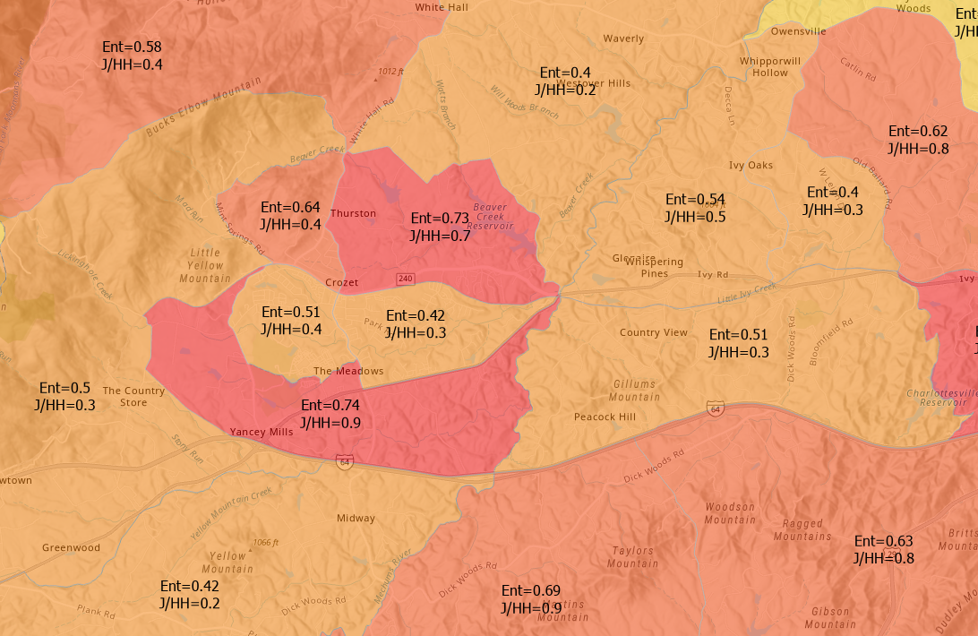
Figure 1. Rural Area with More Homogeneous Land Uses

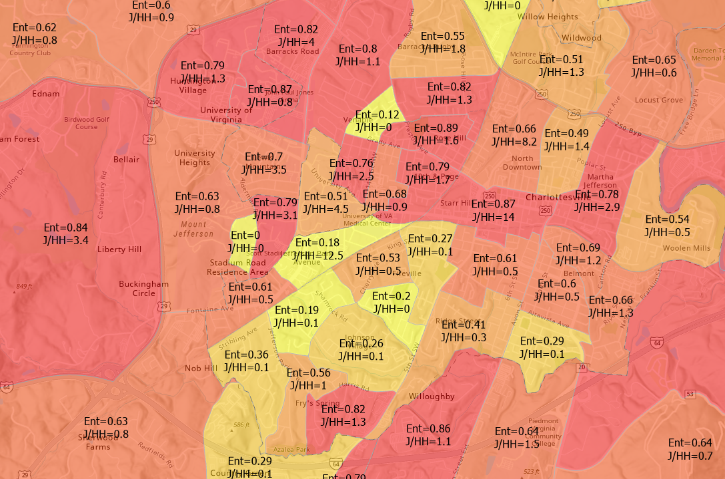
Figure 2. Urban Area with More Mixed Land Uses

Method Used for Virginia

Base Year Values

For the base year (2024) estimates of land use mix, the research team used the entropy as a starting point but chose the smallest value of these two quantities:

- Entropy (e.g., D2A_EPHHM) which is always between 0 and 1
- Entropy multiplied by Jobs per household (e.g., D2A_EPHHM* D2A_JPHH)

The intended impact of this was to use the entropy measure as an upper bound on land use mix but, in locations where entropy was high and number of jobs per household was low to reduce the land use mix accordingly. Thus a spatial join was performed such that the mean values for D2A_EPHHM and D2A_JPHH for each of Virginia’s 5,963 block groups were determined, and then the urban land use mix was calculated.

For example, consider block group 510030110004 in Albemarle County
- Entropy = 0.74
- Jobs/Household = 0.92
- Mixed use proportion is thus 0.74*0.92 = 0.68 because this is smaller than entropy alone.

By contrast, consider block group 515400010001 in downtown Charlottesville.
- Entropy = 0.49
- Jobs/Household = 1.43
- Mixed use proportion is thus 0.49 because this is smaller than entropy*jobs/household

Forecast Year (2045) Values

For the forecast year (2045) estimates, the 2045 mixed-use proportions were held constant at 2024 levels—that is, no changes from 2024 to 2045 are in the files. There are two reasons for this:

- First, the region may wish to have a formal policy target for mixed-use development. Thus, the 2045 values shown in this file indicate that the proportion of each Bzone that is pedestrian friendly will not change. If a locality wishes to increase these proportions—e.g., formally decide to have more walkable neighborhoods—then the way to evaluate this policy is to have a new scenario with higher proportions of MixUseProp than those shown in the bzone_urban_mixed-use_prop.csv file.

- Second, there is uncertainty in long-term urban growth patterns. Population growth varies by region, and applying a uniform increase across all zones could misrepresent local conditions. It is more appropriate to adjust values based on region-specific forecasts. To be clear, Virginia’s population is estimated to reach approximately 10.15 million by 2045, based on linear interpolation between Weldon Cooper Center’s 2040 and 2050 projections, which is a 17.6% increase from 2020. However, this does not necessarily mean MixUseProp will increase: while McKenzie (2023) projects continued urban growth, Lombard (2023) highlights rising move-out rates from cities toward exurbs.

Processing Files Used for Virginia

- The Excel file Bzone_Urban-Mixed-Use_Prop.xslx has, for each Bzone, the GeoID, D2A_JPHH (jobs/households), D2A_EPHHM (the entropy measure labeled as “employment and household entropy”, the “mixed use proportion” all for 2024 data, and three additional attributes not used in these calculations but which localities may choose to adopt:
  - Attribute D2A_WRKEMP (the ratio of workers living in the zone to jobs located in the zone, labeled as “household workers per job”
  - Attribute D1A, which is “Gross residential density (HU/acre) on unprotected land”, and
  - Attribute D1D, which is “Gross activity density (employment + HUs) on unprotected land”

- The Excel file Bzone_Urban-Mixed-Use_Prop.csv has just the GEOID and the mixed use proportion, where 2024 and 2045 values are identical.

Sources

McKenzie, B. Metro Areas Will Grow Larger, Rural Areas Will Grow Older. UVA Today, September 11, 2023.
https://news.virginia.edu/content/metro-areas-will-grow-larger-rural-areas-will-grow-older. Accessed February 22, 2026.

University of Virginia Weldon Cooper Center for Public Service. Virginia Population Estimates, 2024. https://coopercenter.org/virginia-population-estimates. Accessed February 22, 2026.

Lombard, H. After a decade of slow growth, many of Virginia’s exurbs are booming again. January 30, 2023.
https://www.coopercenter.org/research/after-decade-slow-growth-many-virginias-exurbs-are-booming-again. Accessed February 22, 2026.

Scrap for Internal Use

In general, there are four places to look for how to figure out what these attributes mean:

      - The link https://visioneval.github.io/docs/model-inputs.html#verspm-inputs has a definition for each CSV file

      - The document Task 7.2 Simplified Scenario Development guide is available at this link: A Playbook for Simplified Approaches for Creating Scenarios in VisionEval

      - The old VTRC report—which used an older version of VisionEval a while back, is https://vtrc.virginia.gov/media/vtrc/vtrc-pdf/vtrc-pdf/22-R21.pdf

      - Also, John has the Smart Location Database at D:\VE2025\BlockGroupsBZones\Align and \\501-RC-NAS1\Users\John.Miller\LT\Team_Projects\VE_STudio\Bzone_Transit_Service.docx

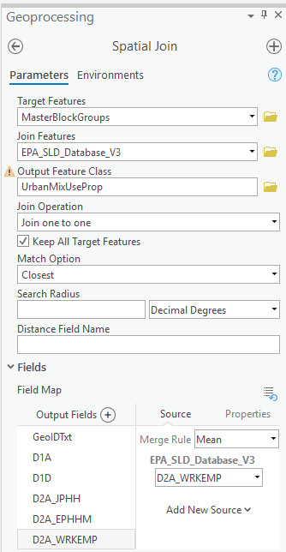

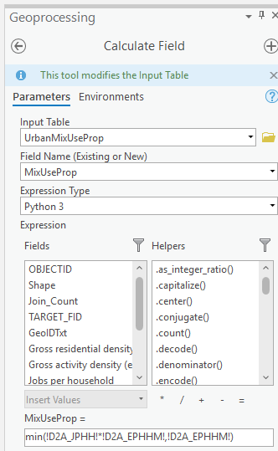

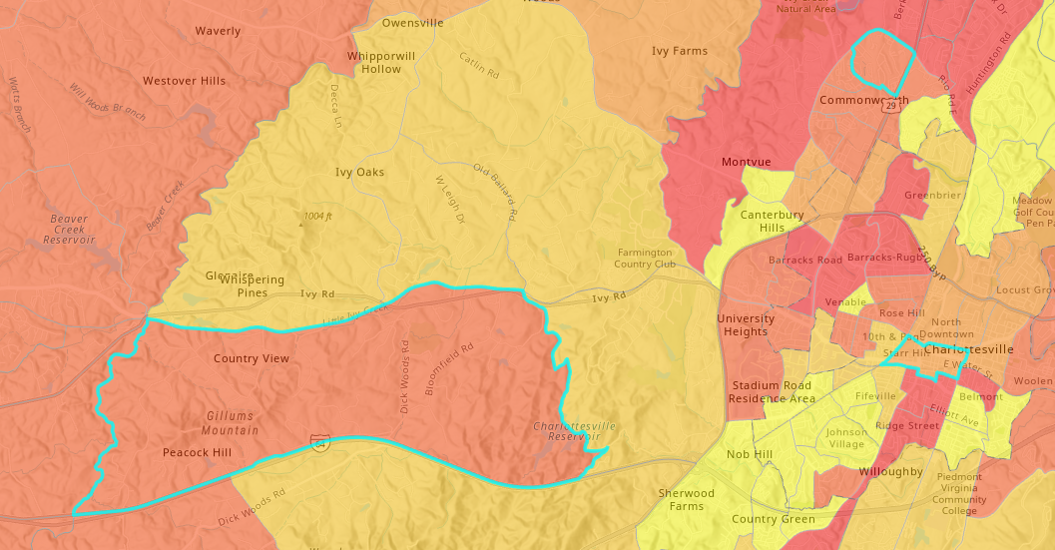

Selection

GeoIDTxt = '510030110004' Or GeoIDTxt = '510030107021' Or GeoIDTxt = '515400010001'
For our meeting March 9

Hi—Let's meet in Room 310 but I have included Teams if we need it. An agenda is below. I may send an updated agenda if we need it but otherwise this is what I propose. Thank you for all your help. Best, John 434-327-2380

- Multimodal module (hopefully final version from Max)
- Progress on running for WPPDC (Sep). How did Sep or anyone define urban, town, or rural?
- Numbered input files (John)—see page 9
- Review of input files
  - Proposed format (John)
  - Changes to that format (all)
  - Agreement on a single zone as an example (all)—Charlottesville and Albemarle Azones
  - Dividing up the 54 input files (all)
  - Rationale for an example scenario based on some, but not all, inputs—possible scenario p. 1
- Looking ahead
  - Schedule for finishing input files and explanation files-- C:\Users\John.Miller1\Downloads\bzones_urban-town_du_proportions.csv Tayyaba
  - Reaching back out to WPPDC
  - Next meeting
  - Summer availability

Proposed format (John)
- Definition of the Input File (most important)
- Possible Scenario (third most important)
- Options for Choosing Inputs (optional)
- General Methods for Estimation (optional)
- Method Used for Virginia (second most important)
- Processing Files Used for Virginia (optional)
- Sources (optional)
- Scrap Work (optional)
Changes to that format (all)

Agreement on a single zone as an example (all—see next page for pictures)
515400010001 (an urban area near Charlottesville’s downtown pedestrian mall),
510030107021 (a suburban area near Route 29 in Albemarle County), and
510030110004 (a rural residential area in Albemarle County).
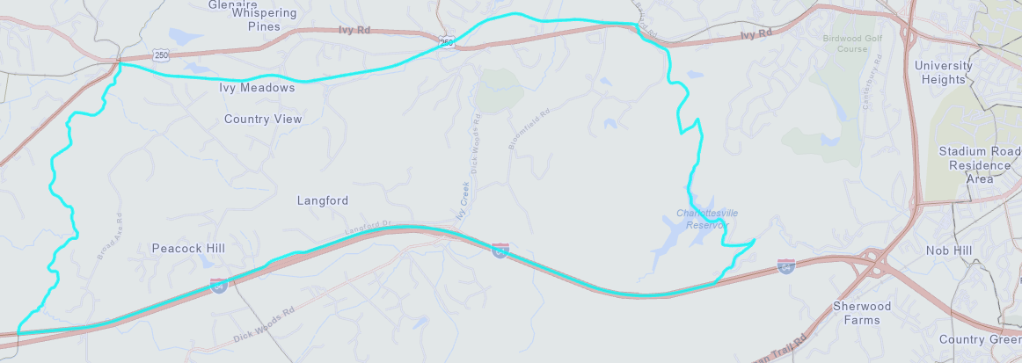
510030110004 (a rural residential area in Albemarle County)
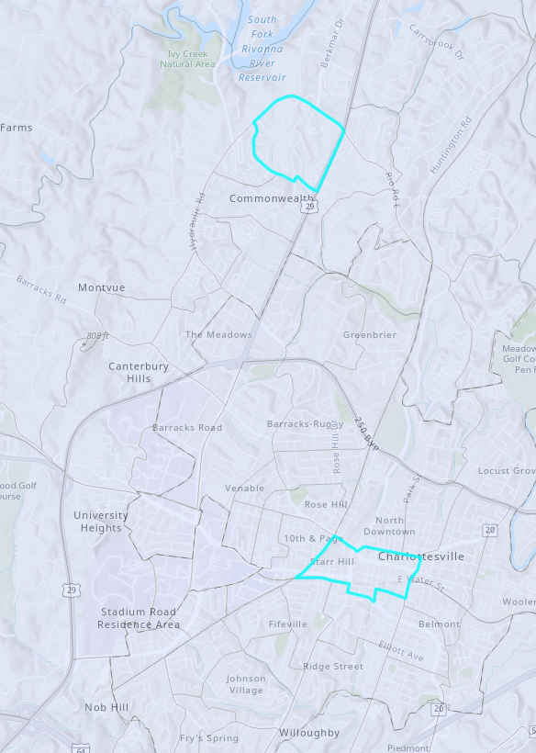
515400010001 (an urban area near Charlottesville’s downtown pedestrian mall)

510030107021 (a suburban area near Route 29 in Albemarle County)

Dividing up the 54 input files (all—see next page—tell me if I missed one)

01_azone_carsvc_characteristics.csv
02_azone_charging_availability.csv
03_azone_electricity_carbon_intensity.csv
04_azone_fuel_power_cost.csv
05_azone_gq_pop_by_age.csv
06_azone_hh_av_veh_per_driver.csv
07_azone_hh_lttrk_prop.csv—This should be deleted
08_azone_hh_pop_by_age.csv
09_azone_hh_veh_mean_age.csv
There is No file Number 10—but we will replace that with the file from Max’s muitmodal file--John
11_azone_hh_veh_own_taxes.csv
12_azone_hhsize_targets.csv
13_azone_lttrk_prop.csv
14_azone_payd_insurance_prop.csv
15_azone_per_cap_inc.csv
16_azone_prop_sov_dvmt_diverted.csv
17_azone_relative_employment.csv
18_azone_veh_use_taxes.csv
19_azone_vehicle_access_times.csv
20_bzone_carsvc_availability.csv
21_bzone_dwelling_units.csv
22_bzone_employment.csv
23_bzone_hh_inc_qrtl_prop.csv
24_bzone_lat_lon.csv
25_bzone_network_design.csv
26_bzone_parking.csv
27_bzone_transit_service.csv
28_bzone_travel_demand_mgt.csv
29_bzone_unprotected_area.csv
30_bzone_urban-mixed-use_prop.csv
31_bzone_urban-town_du_proportions.csv
32_marea_base_year_dvmt.csv
33_marea_congestion_charges.csv
34_marea_dvmt_split_by_road_class.csv
35_marea_lane_miles.csv
36_marea_operations_deployment.csv
37_marea_speed_smooth_ecodrive.csv
38_marea_transit_biofuel_mix.csv
39_marea_transit_fuel.csv
40_marea_transit_powertrain_prop.csv
41_marea_transit_service.csv
42_model_parameters.json
43_other_ops_effectiveness.csv
44_region_base_year_dvmt.csv
45_region_carsvc_powertrain_prop.csv
46_region_comsvc_lttrk_prop.csv
47_region_comsvc_powertrain_prop.csv
48_region_comsvc_veh_mean_age.csv
49_region_hh_ave_driver_per_capita.csv
50_region_hvytrk_powertrain_prop.csv
51_region_prop_externalities_paid.csv
52_region_road_cost.csv

